NINJAL Research Papers: Paper Template Ver. 202507

KOKUGO Kentoª TACHIKAWA Midori^{b}
ªNINJAL
^{b}Ronshu University / Project Collaborator, NINJAL

Abstract
To promote research activities, disseminate research results, and provide training for early-career researchers, the National Institute for Japanese Language and Linguistics (NINJAL) publishes two issues of the journal “NINJAL Research Papers” online per fiscal year. Before starting to compose your manuscript, please read through the “Guidelines for Manuscript Submission,” and refer to them as you write.

Keywords: keyword 1, keyword 2, keyword 3, keyword 4, keyword 5

- Introduction
This document serves to instantiate the “Guidelines for Manuscript Submission for the Journal ‘NINJAL Research Papers’”. Please use this template when you prepare your manuscript.
In addition, please be aware in advance that a PDF version will be published on the NINJAL website, but there are cases where the typesetting may differ from the Word document manuscript.

- Page layout and font
The manuscript shall be on A4 or letter size paper, typed on one side of the page only. For English text, format your document so that a page with no figures, no tables and no example sentences contains about 550 words.

- Heading numbers
In this Journal, the highest unit is “Section.” Numbers are assigned for headings such as “Foreword,” “Introduction,” “Afterword,” and “Conclusion” as well. Headings such as “Foreword” and “Introduction,” are assigned not 0. but rather 1. as the number.
Subdivisions of the main text are numbered as follows: “3. Heading numbers,” and “3.1 Example of a heading one level below Section” (without indentation) with an empty line above the heading (but with none below it).
When referring to Sections in the body of the text, use expression such as “In Section 3” and “As noted in Section 3”.

  - Example of a heading one level below Section
The text begins on the next line after the heading.

  - Example of a heading one level below Section
The text begins on the next line after the heading.

- Tables and figures
Consecutive numbers are assigned to tables and figures, and captions are required. The figure or table itself is centered horizontally with respect to the line.

Table 1 Captions are left-aligned over tables
 | Item A | Item B | Item C
Item abc | 123 | 234 | 567
Item def | 98 | 76 | 54
Item ghi | 987 | 654 | 321

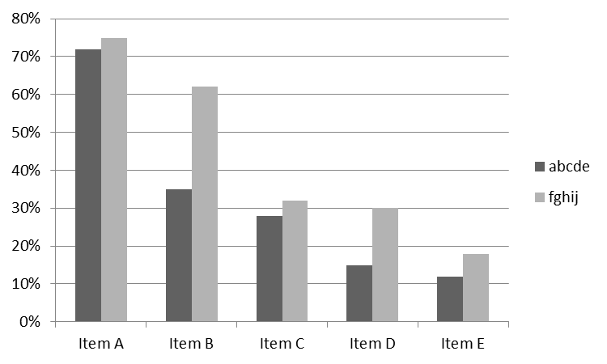
Figure 1 Captions are centered horizontally under figures

Figures, images, graphs, etc., in the manuscript should be in black and white. Color may be used; however, in this case, the authors should give due consideration to the diversity of color vision and try to create figures that are easy to understand both in color, and black and white.
Furthermore, the author is responsible for any copyright processing necessitated by the reprinting of illustrations featured in other written works, and for licensing by related parties with regard to the use or publication of data.

- Presentation of example sentences
Leave single line spaces between the text and the examples. Consecutive numbers in round brackets precede examples, and examples are left-aligned to these numbers without breaks or indentation.

(1) Hanako wa imooto to eiga o mi-ta.
Hanako TOP sister with movie ACC see-PAST
‘Hanako saw a movie with her sister.’

- Notes
Notes are to be endnotes numbered consecutively and grouped at the end of the paper. Alternatively, the contents of notes may be listed as footnotes at the end of each page. Be aware that in the typesetting, the notes will appear as footnotes.

- Citing references
References are limited to only those works which have been cited or quoted in the text or notes, and are to be grouped at the end of the paper. If applicable, sources for example sentences should appear at the end of the paper.
For citation of references in the text and in the notes, follow the practice such as “Sapir (1925) notes that …”
For longer quotations, follow the practice exemplified below:

In the case of longer quotations, put a blank space between the quotation and the text both before and after the quotation, and indent the quotation four spaces. There is no need to surround the quotation with quotation marks. (NINJAL Research Papers Editorial Board 2016: 6)

- Conclusion
We hope that the above will prove to be an easy-to-understand reference for the composition of manuscripts.
For the full text of the “Guidelines for Manuscript Submission for the Journal ‘NINJAL Research Papers’” and the online version of the journal “NINJAL Research Papers” please see the NINJAL website (https://www.ninjal.ac.jp/english/info/publication/papers/).

References
Bloomfield, Leonard (1933) Language. New York: Holt.
Jakobson, Roman, Gunnar Fant and Morris Halle (1963) Preliminaries to speech analysis: The distinctive features and their correlates. Cambridge, MA: MIT Press.
Kiparsky, Paul (1968) Linguistic universals and linguistic change. In: Emmon Bach and Robert T. Harms (eds.) Universals in linguistic theory, 171–202. New York: Holt, Rinehart and Winston.
Postal, Paul (1970) On the surface verb “remind”. Linguistic Inquiry 1: 37‒120.

Related website
National Institute for Japanese Language and Linguistics (2018) The Corpus of Spontaneous Japanese (ver. 2018.01, Chunagon ver. 2.7.2). https://clrd.ninjal.ac.jp/csj/ (accessed May 2025).

国立国語研究所論集
――投稿原稿テンプレート202507版――

国語研人ª 立川 緑^{b}
ª国立国語研究所
^{b}論集大学／国立国語研究所 共同研究員

要旨
国立国語研究所では，国立国語研究所における研究活動の活性化と成果の公表及び所内若手研究者育成を目的として，『国立国語研究所論集』（英語名“NINJAL Research Papers”）を各年度に2回発行します。原稿を執筆する際は，「投稿・執筆要領」に目を通し，執筆の参考にしてください。

キーワード：キーワード1，キーワード2，キーワード3，キーワード4，キーワード5

The asterisk * at the end of the Abstract links to the footnote for the Acknowledgments. Here are examples of Acknowledgements. They should include a sentence like that below. Please refer to https://www.ninjal.ac.jp/research/cr-project/ for information on Collaborative Research Projects. ・If collaborative research project: “This manuscript (or part thereof) contains research results of the NINJAL collaborative research project ‘○○’ (project leader: ○○□□).” ・If joint usage project: “This manuscript (or part thereof) contains research results of the NINJAL joint usage project ‘○○’ (project leader: ○○□□).” ・If Visiting Researcher: “This manuscript (or part thereof) contains research results under the research theme of ‘○○’ during the author’s period of residence at NINJAL from MM/YYYY to MM/YYYY.” ・If the copyright of the manuscript is not held by the author for such reasons as the copyright having been transferred to an academic society: “This manuscript has been submitted with the permission of the XX academic society, which is the copyright holder.” ・If the author has granted permission to only the academic society to exercise the rights of reproduction and public transmission of the manuscript at the request of the academic society: “This manuscript has been submitted with the permission of the XX academic society.” ・(An earlier version of) this manuscript has appeared as a preprint on XXX (https://doi.org/xxxxx/xxxxx).
Both in the text and at the head of the notes themselves, the numbering is in superscript Arabic numerals. Notes that serve only as citations for quotations are not to be used.
In English text, the numbers appear after punctuation. In Japanese, it is before punctuations that the numbers appear.

